What To Turn In for Analog lab 1:

1. A printout of your Single Stage Differential Amplifier schematic.

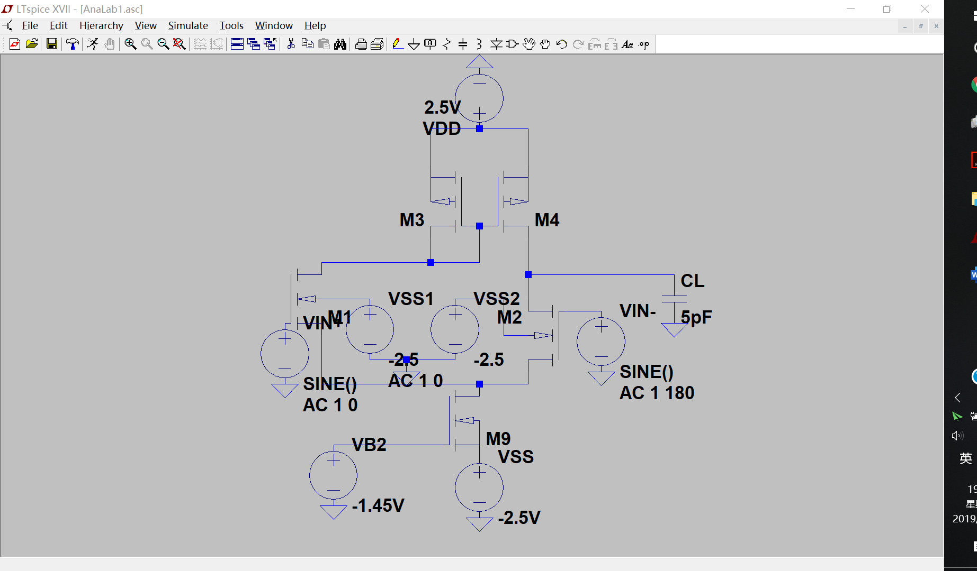

2. A printout of the LTspice frequency response simulation curve(include amplitude and phase response)

The frequency response of the vout

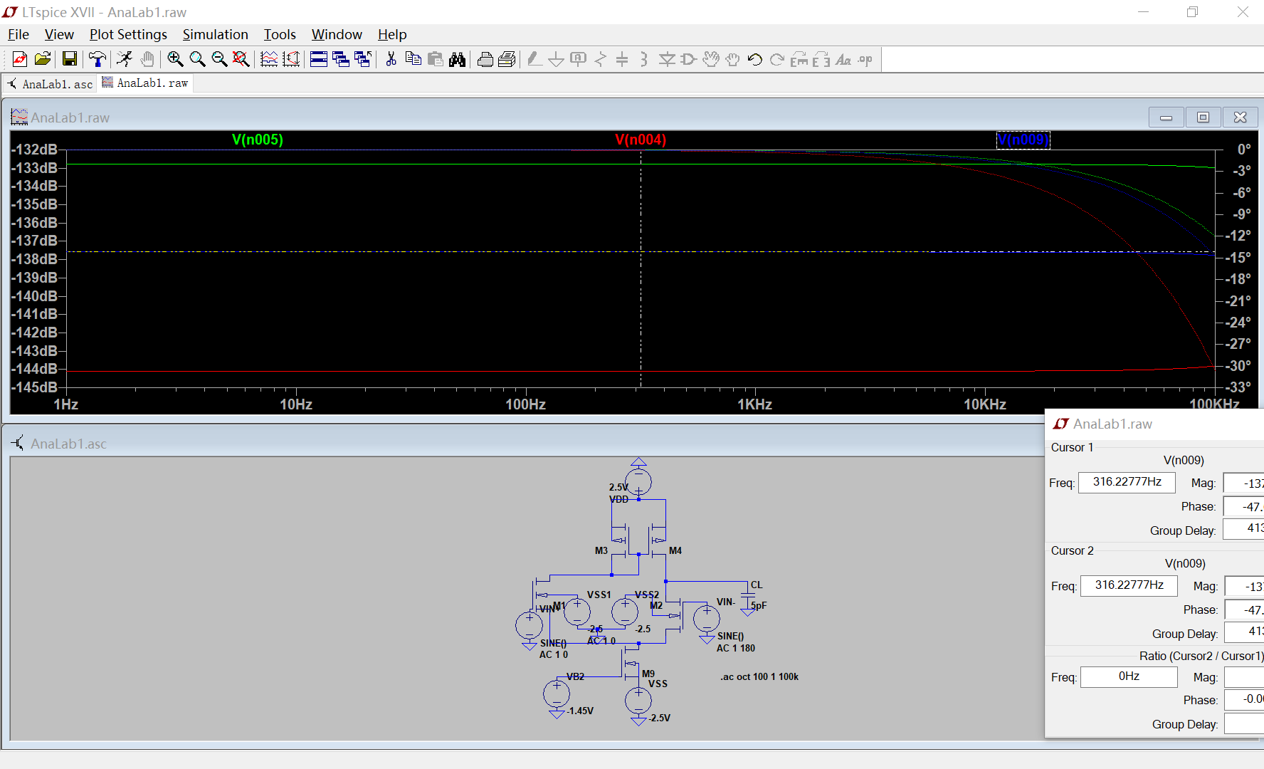

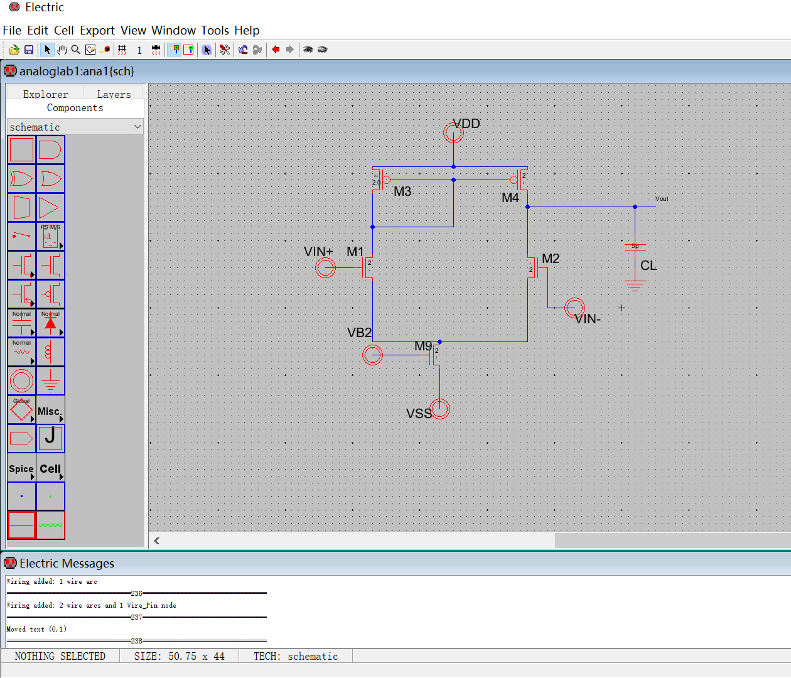

3. A printout of your Single Stage Differential Amplifier layout

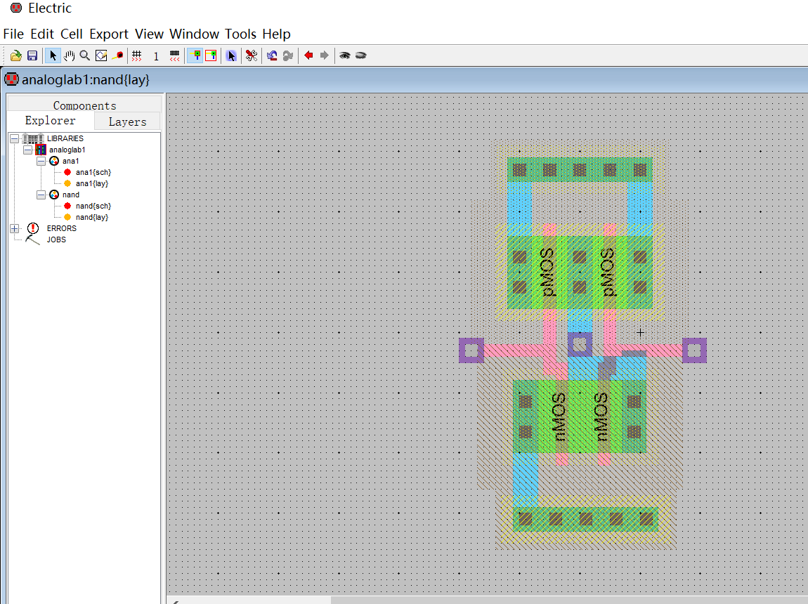

4. What is the verification status of your Single Stage Differential Amplifier layout? Does it pass DRC? ERC? NCC?

Yes

5. Origin electric-9.07 file of the schematic and layout of your Single Stage Differential Amplifier

6. Origin LTspice file for your Single Stage Differential Amplifier frequency response simulation.

All the origin file should be as “first name_Sir name_GUID.jelb” (schematic and layout file) and “first name_Sir name_GUID.asc”(LTspice simulation file). Of course you can use other software to simulate the frequency response and change the file extension name accordingly.

For the lab report file name, it should be “First name Surname_GUID number_Analog Lab1.docx” or ““First name Surname_GUID number_Analog Lab1.pdf”